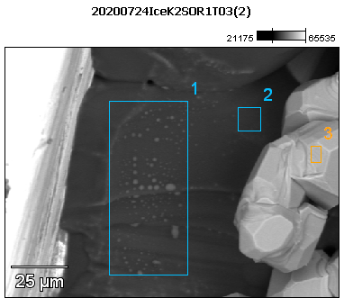

Image Name: 20200724IceK2SOR1T03(2)

Image Resolution: 512 by 384

Image Pixel Size: 0.29 µm

Acc. Voltage: 12.0 kV

Magnification: 850

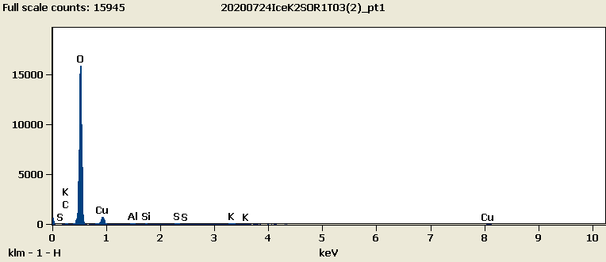

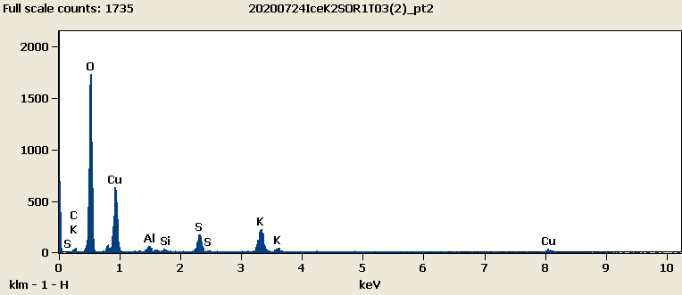

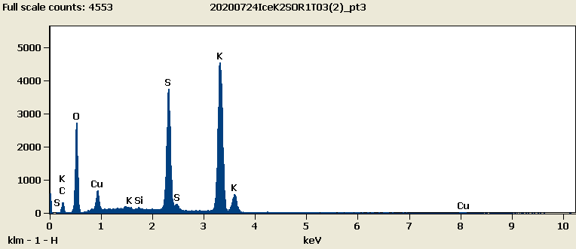

Weight %

|  |  |  |  |  |  |  |  |
| --- | --- | --- | --- | --- | --- | --- | --- |
|  | ***C-K*** | ***O-K*** | ***Al-K*** | ***Si-K*** | ***S-K*** | ***K-K*** | ***Cu-L*** |
| ***20200724IceK2SOR1T03(2)_pt1*** | 0.83 | 78.31 | 0.36 | 0.24 | 0.91 | 2.32 | 17.03 |
| ***20200724IceK2SOR1T03(2)_pt2*** | 2.84 | 46.78 | 1.20 | 0.37 | 5.09 | 10.28 | 33.44 |
| ***20200724IceK2SOR1T03(2)_pt3*** | 4.67 | 27.33 |  | 0.15 | 19.74 | 41.77 | 6.36 |

Weight % Error (+/- 1 Sigma)

|  |  |  |  |  |  |  |  |
| --- | --- | --- | --- | --- | --- | --- | --- |
|  | ***C-K*** | ***O-K*** | ***Al-K*** | ***Si-K*** | ***S-K*** | ***K-K*** | ***Cu-L*** |
| ***20200724IceK2SOR1T03(2)_pt1*** | ±0.11 | ±0.29 | ±0.04 | ±0.04 | ±0.09 | ±0.14 | ±0.28 |
| ***20200724IceK2SOR1T03(2)_pt2*** | ±0.26 | ±0.44 | ±0.08 | ±0.08 | ±0.23 | ±0.41 | ±0.60 |
| ***20200724IceK2SOR1T03(2)_pt3*** | ±0.21 | ±0.26 |  | ±0.03 | ±0.15 | ±0.29 | ±0.18 |

# Cations

|  |  |  |  |  |  |  |  |
| --- | --- | --- | --- | --- | --- | --- | --- |
|  | ***C-K*** | ***O-K*** | ***Al-K*** | ***Si-K*** | ***S-K*** | ***K-K*** | ***Cu-L*** |
| ***20200724IceK2SOR1T03(2)_pt1*** | 0.00 | 0.00 | 0.00 | 0.00 | 0.00 | 0.00 | 0.00 |
| ***20200724IceK2SOR1T03(2)_pt2*** | 0.00 | 0.00 | 0.00 | 0.00 | 0.00 | 0.00 | 0.00 |
| ***20200724IceK2SOR1T03(2)_pt3*** | 0.00 | 0.00 |  | 0.00 | 0.00 | 0.00 | 0.00 |